Dose Calculator Module

**1.Introduction**

The purpose of this module is to provide HCPs the ability to calculate the amount of several medical drugs to be provided to a patient. Currently, there are three calculators, which will be made (and can be expanded based on the requirements gathered). The calculators are part of a single module, but the CMS Editors are able to select which ones to configure on their website.

**2. Types of calculators and their field**

- Ninlaro:

Each of the fields provides a dropdown with a selection of answers (up to three). Once all answers per page have been filled, the HCP can navigate to the next page (page two or three). At the bottom of each page there is a points calculator (green bar).

Upon completion of all fields in all three pages, there is a dropdown for the age - needs to be filled. There is also a button for calculating the overall results, which are then displayed.

Fields:

* For the background color of the calculator
* For the text color
* For the dropdowns border color
* For the dropdowns text color
* For the age input border color
* For the age input background color
* For the age input text color
* For the total score field border color
* For the total score fields background color
* For the total score field text color
* For the result button border color
* For the result button text
* For the result button background color
* For the result button text color
* For the final score field border color
* For the navigation button border color
* For the navigation button background color
* For the navigation button background color on hover
* For the reference links in the footer
* For the title color
* For the back to top button color



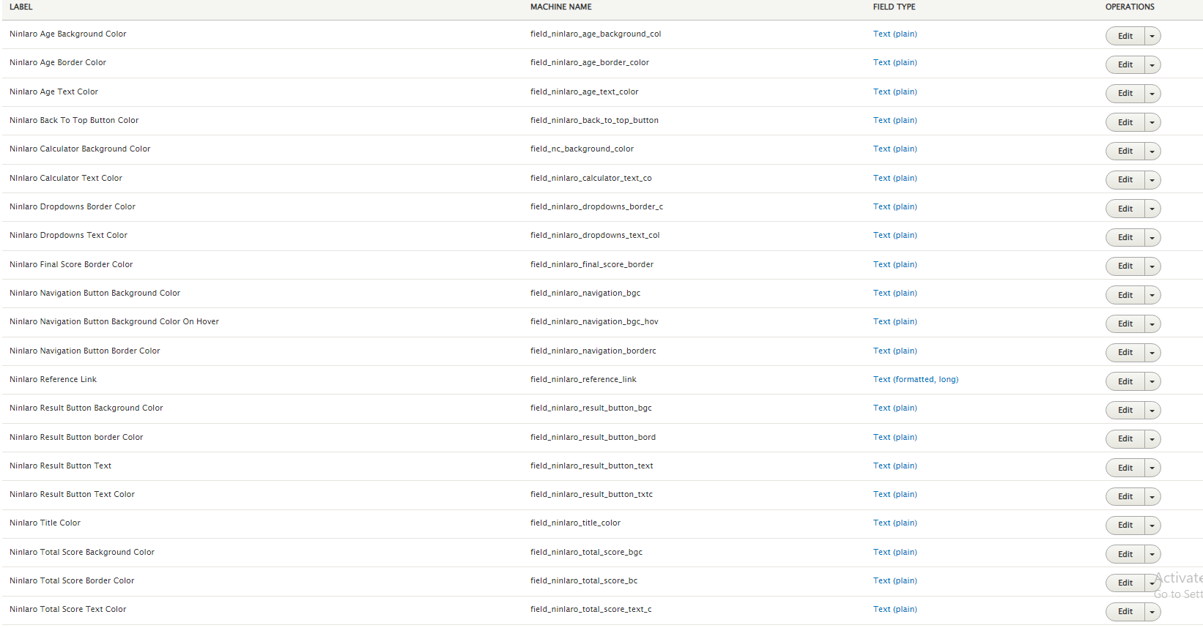

-Advante:

The calculator displays a table with information, which is filled from the CMS.

At the bottom of the table there are three fields that need to be populated by the HCP, which will lead to calculation of the dose to be prescribed to the patient. There are requirements for the values (validations for max numbers to be added in each of the three boxes).

There is also a button for “Calculate” and another one for “Reset Calculation”. The third button is for exiting the website - upon click, a pop-up appears with a message that the HCP is about to leave the website (two options - Yes and Cancel).

Fields:

* For the back to top button color
* For the table subheader background color
* For the table subheader text color
* For the calculate button background color
* For the calculate button text color
* For the calculate button text
* For the calculate button background color on hover
* For the calculate button text color on hover
* For the even rows background color
* For the even rows text color
* For the inputs background color
* For the inputs text color
* For the labels color
* For the odd rows background color
* For the odd rows text color
* For the placeholders color
* For the reset button background color
* For the reset button background color on hover
* For the reset button text
* For the reset button text color
* For the reset button text color on hover
* For the title color
* For the reference links
* For the recommendations table filling
* For the table header text color
* For the table header background color

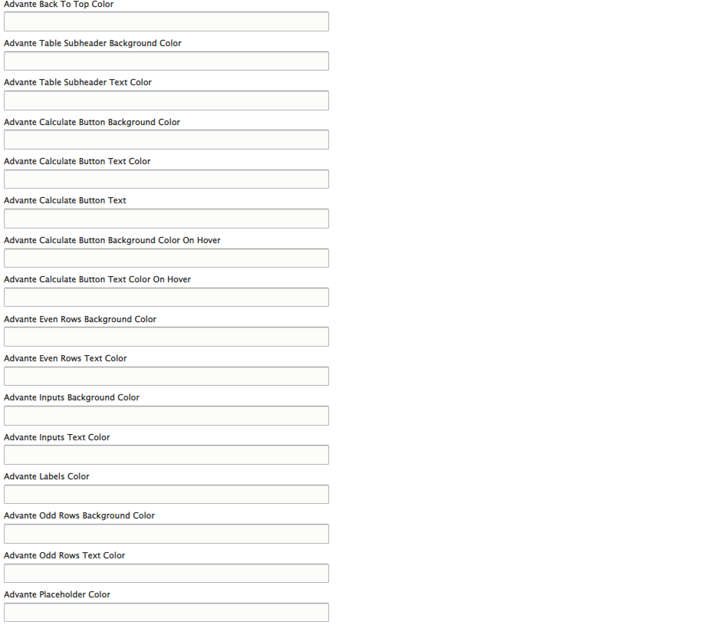

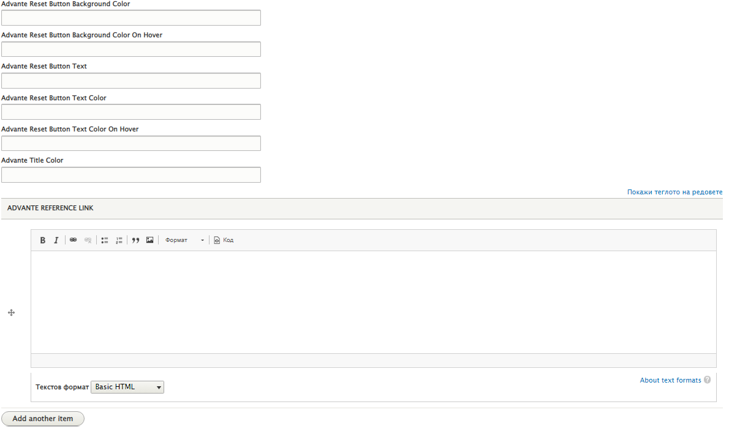

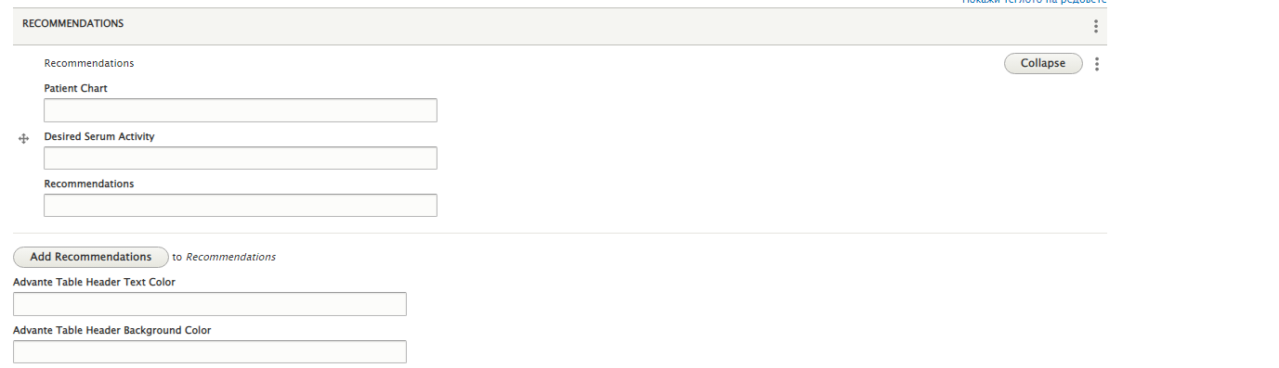



-Feiba:

The Febia calculator is similar to the Advante in terms of structure and functionality. There is also a table with information, but has only two fields with information to be added by the HCP for the calculation to happen. There is also a “Calculate” and a ”Reset Calculation” button.

A text field with references is also present and is editable from the CMS.

The third button is for exiting the website - upon click, a pop-up appears with a message that the HCP is about to leave the website (two options - Yes and Cancel).

Fields:

* For the back to top button color
* For the calculate button background color
* For the calculate button text color
* For the calculate button text
* For the calculate button background color on hover
* For the calculate button text color on hover
* For the even rows background color
* For the even rows text color
* For the inputs background color
* For the inputs text color
* For the labels color
* For the odd rows background color
* For the odd rows text color
* For the placeholders color
* For the reset button background color
* For the reset button background color on hover
* For the reset button text
* For the reset button text color
* For the reset button text color on hover
* For the title color
* For the reference links
* For the recommendations table filling
* For the table header text color
* For the table header background color



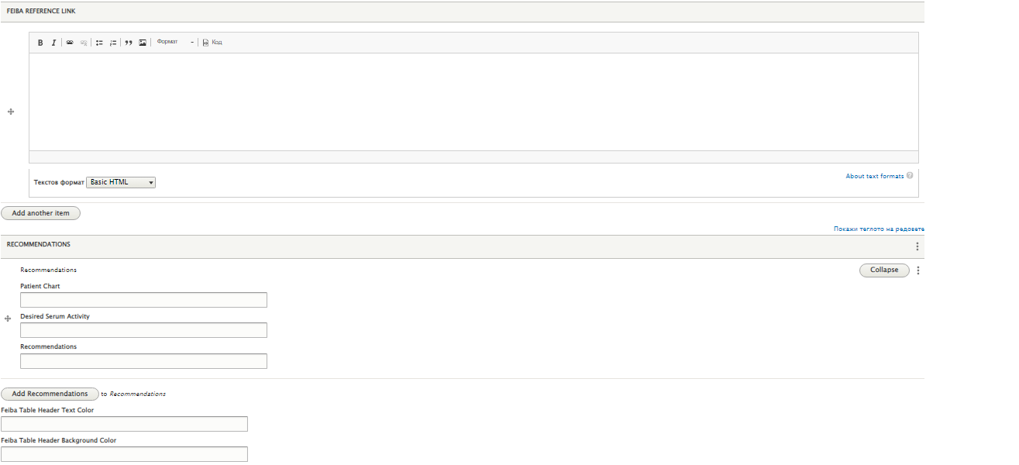



The editors can configure which calculator to be displayed in the website when they  go in the edit of the corresponding calculator and in the field menu settings click the checkbox provide a menu link.

Note: There should not be any other elements within the pages of the calculator because they might break the view.